YEAR 12 PHYSICS, UNIT 4

Power Transmission, Wave-Particle Duality and Quantum Test

NAME: ____________________________________

TOTAL MARKS: /59

TIME ALLOWED FOR THIS PAPER

Working time for paper: 55 minutes

INSTRUCTIONS TO CANDIDATES

Answer all questions.

Sufficient working should be shown on all calculation, with a complete, logical, clear sequence of reasoning showing how the final answer was arrived at. Correct answers which do not show full working will not necessarily be awarded full marks.

Give final answers to three significant figures, using scientific notation if needed, and include appropriate units where applicable.

When estimating numerical answers or reading information from a chart or graph, give final answers to a maximum of two significant figures and include appropriate units where applicable. Clearly state any assumptions or estimations which are made.

Question 1 [4 Marks]
Light can be said to have a dual nature. For the following phenomena, state whether each provides evidence in support of either the wave model or the particle model for light, and give a brief description of each.

- Polarisation: (2)
______________________________________________________________________________
______________________________________________________________________________
______________________________________________________________________________
______________________________________________________________________________
- The Ultraviolet Catastrophe: (2)
______________________________________________________________________________
______________________________________________________________________________
______________________________________________________________________________
______________________________________________________________________________
Question 2 [4 Marks]
Some substances appear to glow under ultraviolet light, and immediately cease to glow when the ultraviolet light is removed.

- What is the name of this phenomenon? (1)

- Explain how this phenomenon occurs. Include a labelled diagram in your explanation. (3)

Question 3 [4 marks]
The diagram below shows part of the circuit for a burglar alarm.
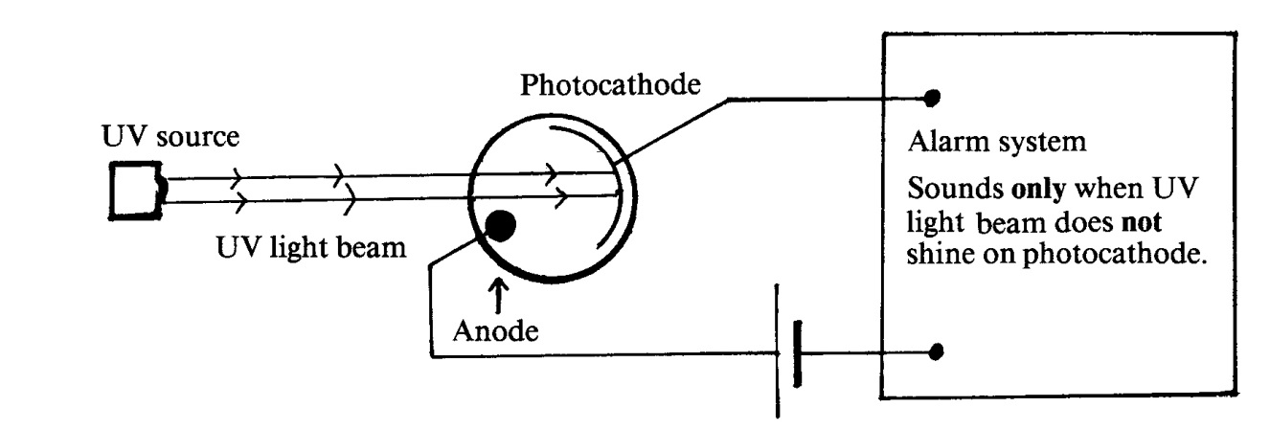
The alarm system is arranged in such a way that, when ultra-violet (UV) light shines on the photocathode, the alarm does not sound but when the UV light beam is broken the alarm will start to sound.

a) Which of the statements (A-D) below is the best explanation of the effect of shining UV light on the photocathode? Circle one statement. (2)
A The UV light photons eject electrons from the photocathode causing an electric current to flow in the circuit.
B The UV light photons eject positive charges from the photocathode causing an electric current to flow in the circuit.
C The UV light prevents electrons from being ejected from the photocathode, hence the alarm sounds only when the beam is broken.
D The UV light deflects electrons which normally flow from the photocathode to the anode.

The ultra-violet light source is now replaced by a source of red light.

b) Which of the statements (A-D) below best describes the result of this replacement? Circle one statement. (2)
A The alarm will definitely operate as normal.
B The alarm will now ring whether or not the light beam is broken.
C The alarm will now ring when the light beam is shining but will stop when the beam is broken.
D Whether or not the alarm will operate normally depends on the value of the work function of the photocathode material.

Question 4 [4 Marks]
The electromagnetic spectrum of the star Betelgeuse is shown below. Like most stars, the spectrum is very close to that of an ideal black body radiator. The range of wavelength of visible light is shown by the vertical column (not shown in colour).

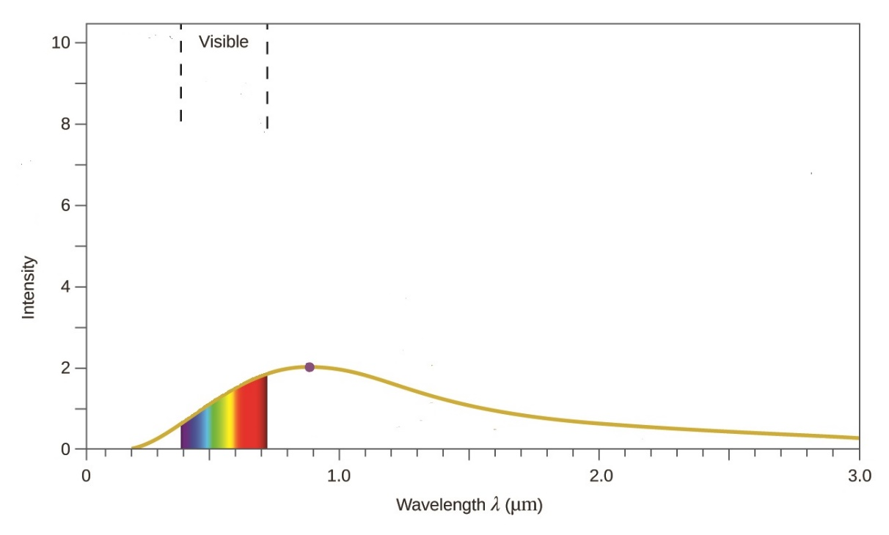
Emission spectrum of Betelgeuse
- What colour would you expect Betelgeuse to appear? __________ (1)

- Wein’s law relates surface temperature (in Kelvin) to the peak wavelength of an ideal black body emission spectrum:
$$λ_{peak}= \frac{b}{T}$$
where b is a constant = 2.898x10⁻³ m K
Use this law to evaluate the surface temperature of Betelgeuse (1)

- Betelgeus’ neighbouring star Bellatrix has a much hotter surface temperature of over 20000 K. Draw a curve on the graph above to show a possible spectrum of Bellatrix (you do not need to calculate the peak wavelength) (2)

Question 5 [4 marks]
An exoplanet is a planet that orbits a distant star. They have been discovered up to 3000 light years from our solar system. Despite being so far away, gaseous elements in the outer atmosphere of an exoplanet can be identified by studying light from the star that has passed through the planet’s atmosphere and arrived here on Earth. The diagram below may help to picture this process. (Note that the star is a blackbody radiator, so that the light it emits, before passing through the atmosphere of the exoplanet, may be considered to be a continuous spectrum).
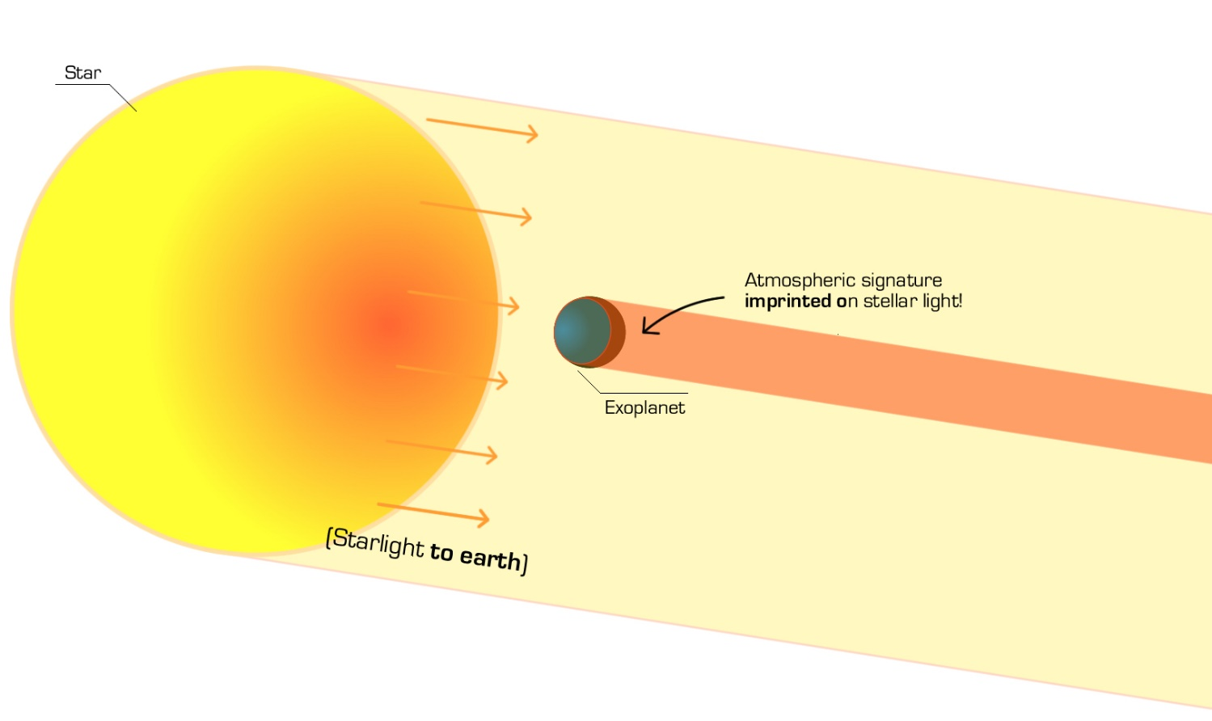
- What kind of spectrum (line emission or line absorption) is observed on Earth when looking at the light which has passed through the planetary atmosphere? __________________ (1)
- Explain how this spectrum can be used to identify the elements in the planet’s atmosphere (3)
________________________________________________________________________________
________________________________________________________________________________
________________________________________________________________________________
________________________________________________________________________________
________________________________________________________________________________
Question 6 [4 marks]
A 600 W radio transmitter uses a metallic aerial to broadcast a signal. It does this by oscillating electrons in the aerial. The radio transmission has a wavelength of 680 m.
- Calculate the frequency of the oscillating electrons that cause the signal to be transmitted. (1)

- Determine how many photons are transmitted in a 5 second pulse. (3)

Question 7 [4 Marks]
An aurora is the appearance of coloured “curtains” of light in the sky near the Earth’s poles. The light comes from the atoms high in the atmosphere which have been “excited” by streams of charged particles entering the atmosphere from the sun or from the Earth’s radiation belts. The green colour in an aurora is due to the emission from excited oxygen atoms and has a wavelength of 565 nm.
A
C
B
E₃ = -1 eV

E₂ = -3.2 eV

E₁ = -5.2 eV

Part of the energy level diagram for oxygen is shown on the right:

Which electron transition (A, B or C) is responsible for the green light? (Show all calculations and reasoning).

Question 8 [5 Marks]
The diagram shows some energy levels, in eV, of an atom.
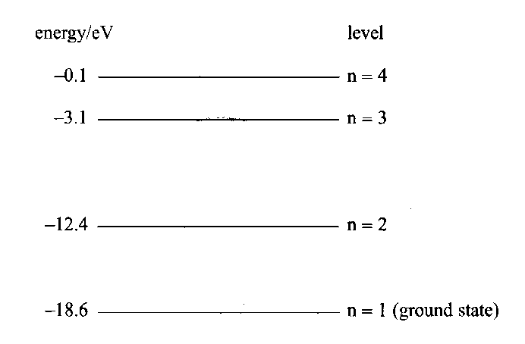
a) How many emission lines are possible in total between these energy levels? (1)

b) What is the ionisation energy, in eV, for an electron in the ground state? (1)

In its ground state, the atom is bombarded by an incident electron with 2.1 x 10⁻¹⁸ J of energy.

c) Calculate the possible energies, in eV, with which this incident electron could be scattered from the atom after the collision. (3)

Question 9 [8 marks]

In early experiments to investigate the photoelectric effect, a beam of light of a single frequency was directed at a clean surface of potassium metal. The maximum kinetic energy of electrons which were ejected from the metal was measured.

When the experiment was repeated with different frequencies of light the maximum kinetic energy of electrons depended on the frequency of the light as shown below.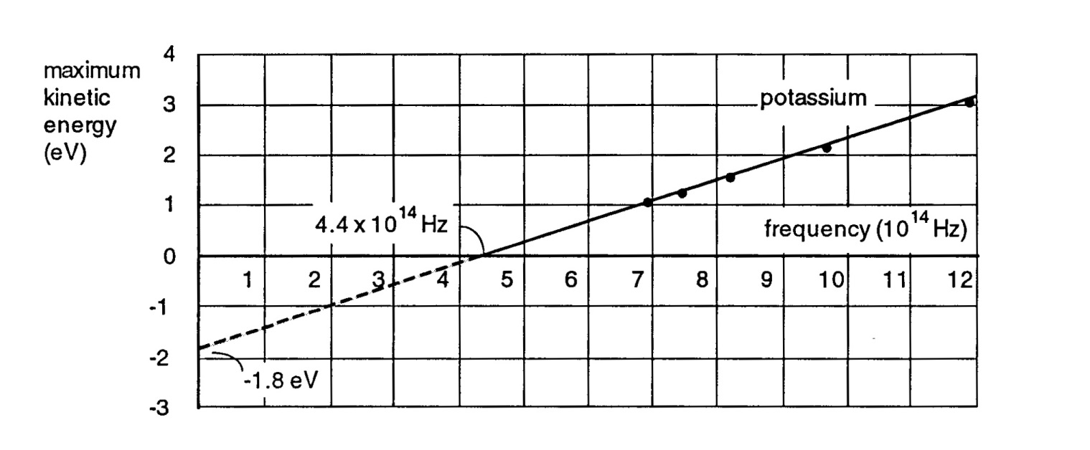
a) What is the minimum energy of a light photon that can eject an electron from potassium metal? (Answer in units of eV) (1)

The graph above shows that electrons ejected by light of frequency 6.0 x 10¹⁴ Hz have a maximum kinetic energy of 0.7 eV. The maximum kinetic energy of electrons ejected by light of frequency
1.2 x 10¹⁵ Hz is 3.2 eV

b) Explain why the maximum kinetic energy of electrons ejected by light of a higher frequency is greater than the maximum kinetic energy of electrons ejected by light of a lower frequency. (2)

___________________________________________________________________________
___________________________________________________________________________
___________________________________________________________________________
___________________________________________________________________________
___________________________________________________________________________

c) Light of frequency 9 x 10¹⁴ Hz is shone on the sample and the potential bias is reversed. Calculate the minimum reverse bias needed to stop the photo current (i.e. the stopping voltage). (3)

The minimum photon energy required to eject electrons from copper is approximately double the value for potassium.

d) Which of the graphs below would best describe the results if the experiment were repeated with copper instead of potassium? Explain your choice, commenting on the slope of the lines for potassium and copper and the points where the lines cross the frequency axis. (2)

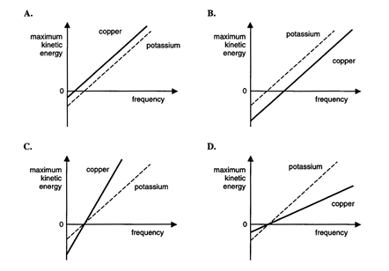
Answer: _______

Explanation: _____________________________________________________________________
_______________________________________________________________________________
_______________________________________________________________________________

Question 10 [7 Marks]
- Calculate the de Broglie wavelength for an electron after it is accelerated through a 200-V potential: (2)

- Use de Broglie’s equation to estimate the momentum of a photon of visible light: (3)

- Which of the following are accurate statements about de Broglie’s postulate (circle one choice underneath the statements) (2)
  - It suggested a reason for Bohr’s quantisation of electron energy levels in atoms.
  - It suggested that electrons in atoms can be considered as standing waves
  - It explained why electrons have momentum
  - The location of particles in motion can be considered to be ‘spread out’ over a distance rather than located at a particular point.

1 & 4 1, 2 & 4 3 & 4 all are true

Question 11 [11 Marks]

A small town is supplied with electricity from a smal hydroelectric generation plant about 20 km from
the town. Electricity is transmitted through a high-voltage transmission lines. The voltage supplied at
the generator end is 50 000 volts (RMS). The RMS current in the lines is 15 amperes. At the edge of
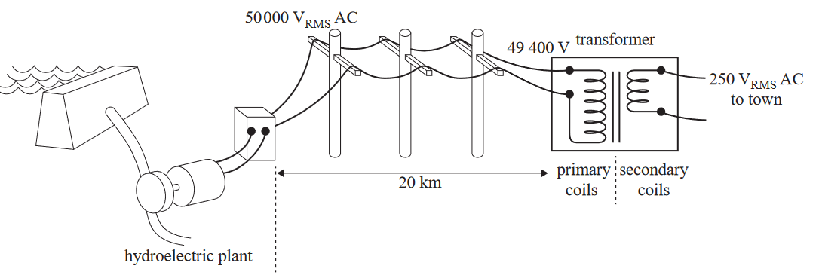
town a substation transformer converts this to 250 V. This is shown in the figure below.
Substation transformer

- Calcuate the power supplied by the plant. (1)

- The voltage that is delivered to the substation transformer is 49 400 V. Calculate the total resistance of the transmission lines. (2)

- The primary coil in the substation transformer has 9880 turns. Calculate the number of turns in the secondary coil (assume no power loss). (2)

- The high voltage transmission lines are held by towers at a height of 12 m. Calculate the mean magnitude of the magnetic field that would be experienced at ground level due to the 15 A overhead current. (2)


12 m

- Some townspeople are concerned about the high voltage towers and their associated magnetic fields. They suggest that the power could be more safely supplied at a lower voltage. Clearly explain why this would result in large losses of energy. (3)

_____________________________________________________________________________________________________________________________________________________________________________________________________________________________________________________________________________________________________________________________________________________________________________________________________________________________________________________________________________________________________________________________________________

- Calcuate the peak voltage of the town supply. (1)

END OF TOPIC TEST

